The dataset provided (link is on the website) contains measurements from three species of penguins: Adélie, Gentoo, and Chinstrap. For each penguin, the following features were recorded: culmen length, culmen depth, flipper length, body mass, and sex. The data also includes the island where each penguin was observed.
Instructions:
1. Visualising Culmen Length Across Species: Create a figure that displays the mean and variance of the culmen length (the length of the penguin’s bill) for each species (Adélie, Gentoo, Chinstrap). Use appropriate visual tools (e.g., bar plots with error bars or box plots) to clearly represent the data for each species.
2. Correlation Analysis Produce a second figure (a single figure or composite of multiple graphs) that explores the relationships between culmen length and the other numerical features (culmen depth, flipper length, body mass) across the species. Your figure should help identify any significant correlations or patterns between these features.
3. Figure Placement and Annotations Place both figures in the box below with descriptive captions. In <50 words, describe your methods for creating the figures, including the tools or libraries used (e.g., Microsoft Excel (or open-source equivalent), Python, R, MATLAB, etc., and any large language models such as ChatGPT, Claude etc). In another <100 words, briefly interpret the results of your visualisations.
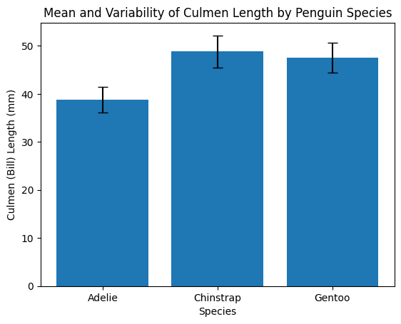
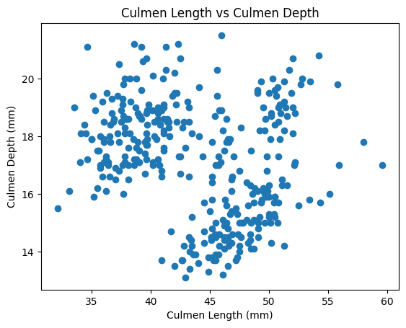
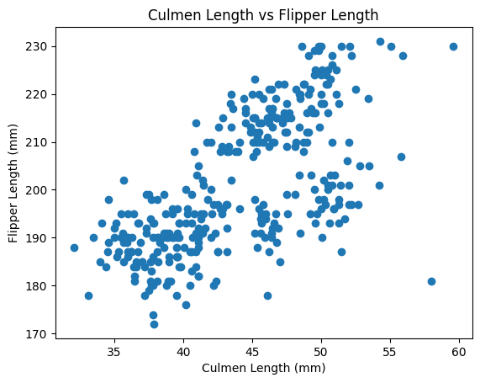
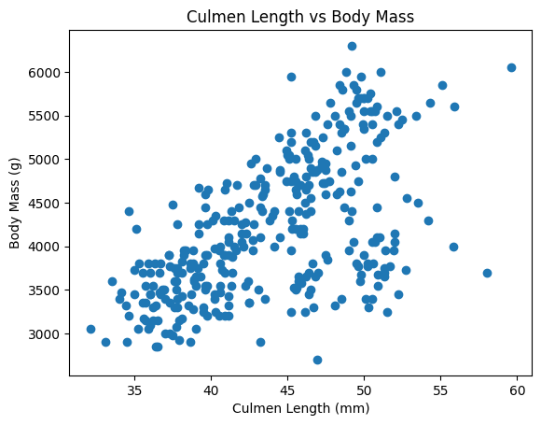
Q6: Analysing the Penguin Dataset
Figure 1. Mean and variability of culmen length by species.
The bar chart shows the average culmen (bill) length for Adélie, Chinstrap, and Gentoo penguins, with error bars representing variability (standard deviation). Chinstrap penguins have the longest mean culmen length, Adélie the shortest, with Gentoo in between.
Figure 2. Relationships between culmen length and other features.
The scatter plots show culmen length versus culmen depth, flipper length, and body mass. Culmen length shows a weak-to-moderate relationship with culmen depth, but clearer positive relationships with flipper length and body mass, indicating that penguins with longer bills tend to be larger overall.
Methods (<50 words).
Figures were created using Python with the pandas library for data handling and matplotlib for visualisation. The dataset was cleaned by removing missing values, then grouped summaries and scatter plots were generated. ChatGPT was used to assist with code development and interpretation.
Interpretation (<100 words).
The visualisations indicate clear morphological differences among species. Chinstrap penguins have the longest bills on average, while Adélie penguins have the shortest. The positive associations between culmen length, flipper length, and body mass suggest that bill size scales with overall body size. These patterns reflect species-specific adaptations and support the use of morphological measurements for distinguishing penguin species.

